**Software Construction & Development (SE-308-B)**



**Stage – 03 (Prototyping)**

Project Title:

**POS (Point of Sale)**

Submitted by:

**Moazam Attiq (221400003)**

**Maida Kosser (221400091)**

Submitted to:

**Mam Sajiya Tariq**

**BS Software Engineering (V)**

**GIFT University, Gujranwala**

1. 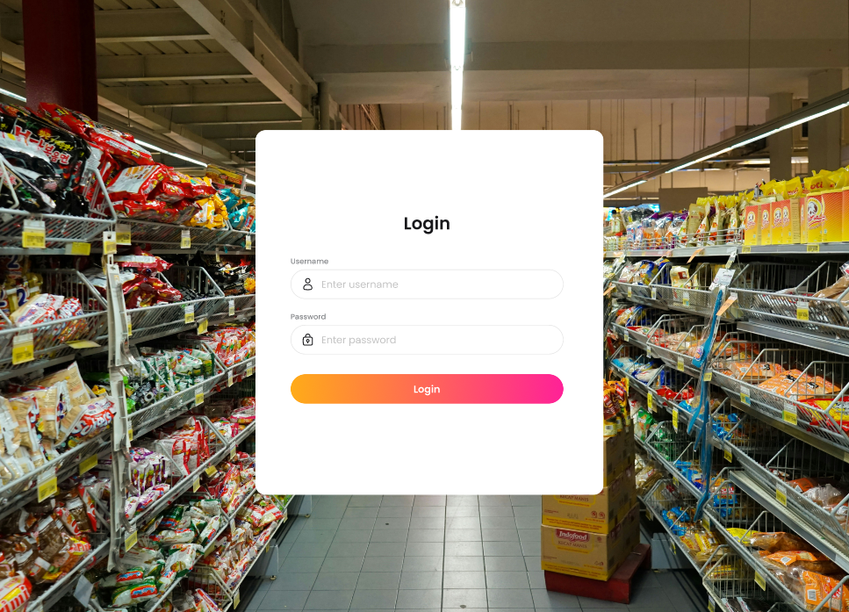**Mock ups Using Figma Tool:**

This is a login page where users need to enter their credentials, including their username and password, to log in.

**FR-1: Product Management**

* 1. 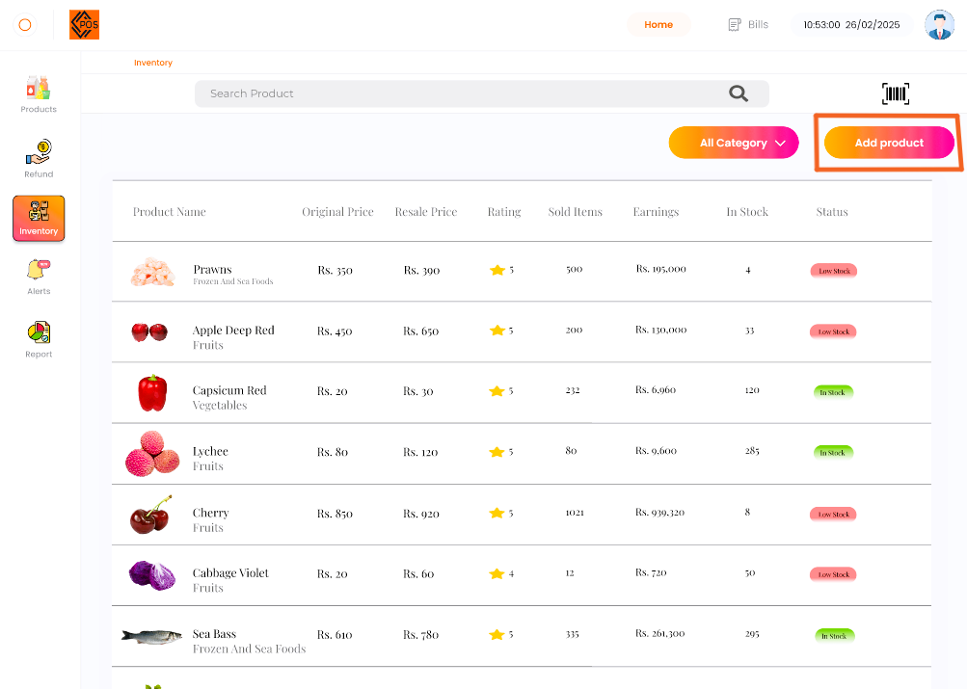 **Add Product to inventory:**

In this inventory system, products are being added using the **"Add Product"** button, which has been highlighted for emphasis.

* 1. 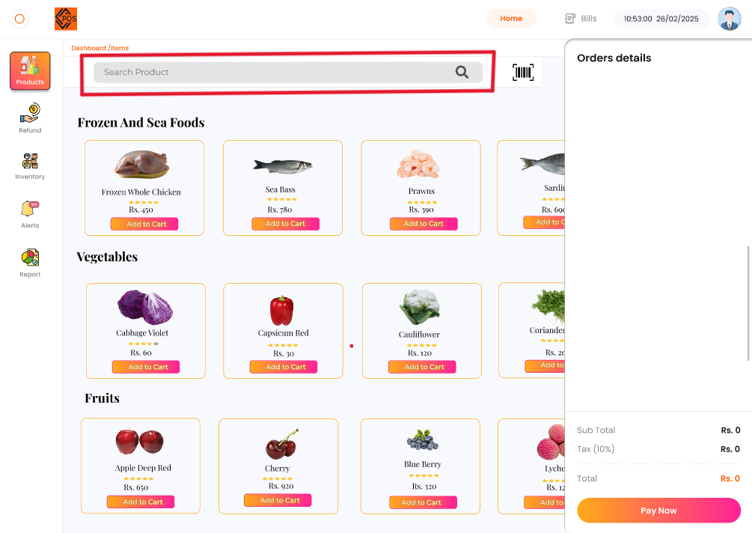 **Search Product:**

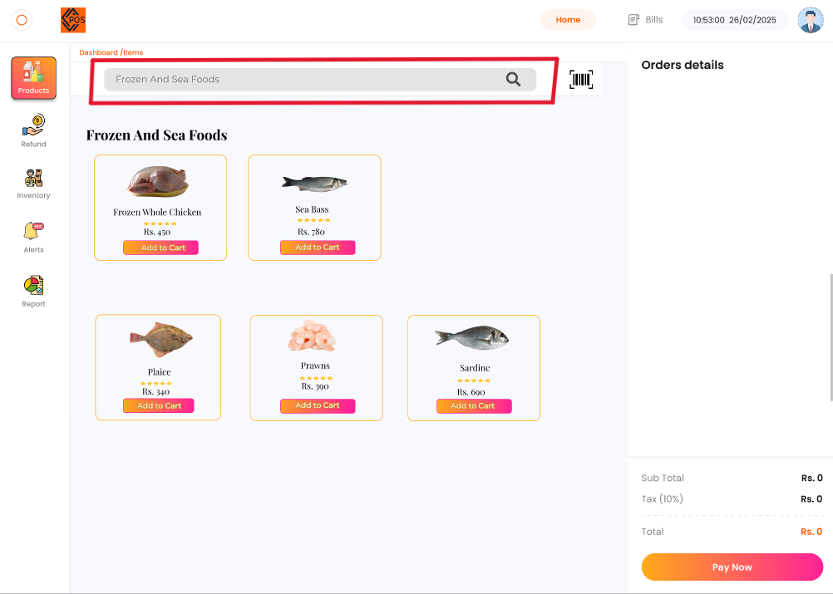Any product can be searched using the **search box**.

**"Frozen and Sea Foods"** have been searched using the **search box**, and all matching items have been displayed.

* 1. **Scan Products:**

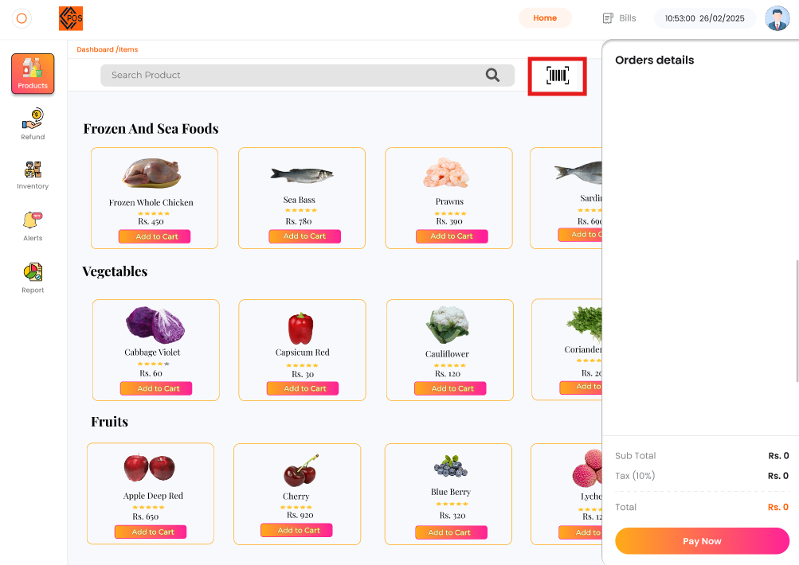

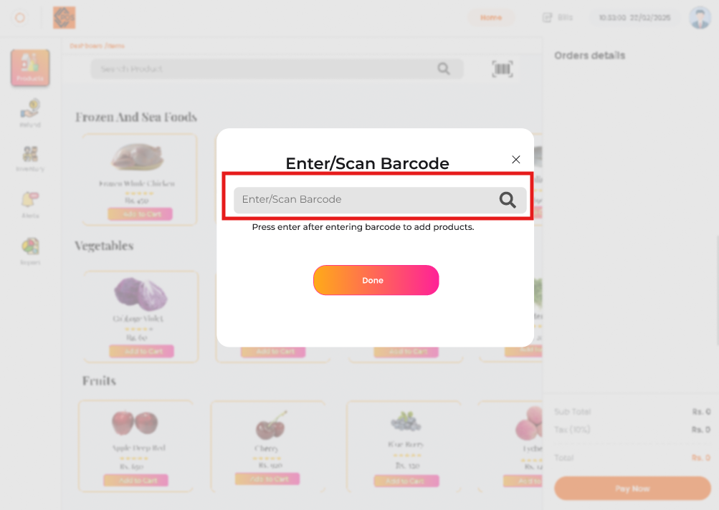The products can be scanned using the **scanner, which is being highlighted.**

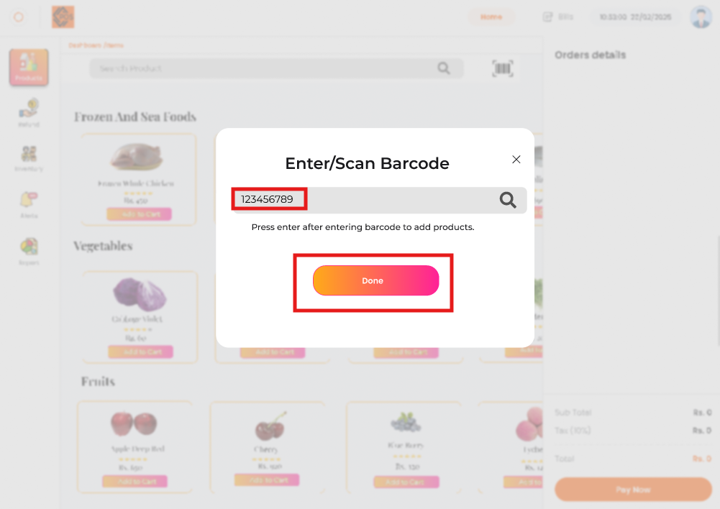Enter or Scan the Bar Code in the highlighted box. In Below picture the bar code entered or Scanned.

* 1. **Add Products to Cart:**

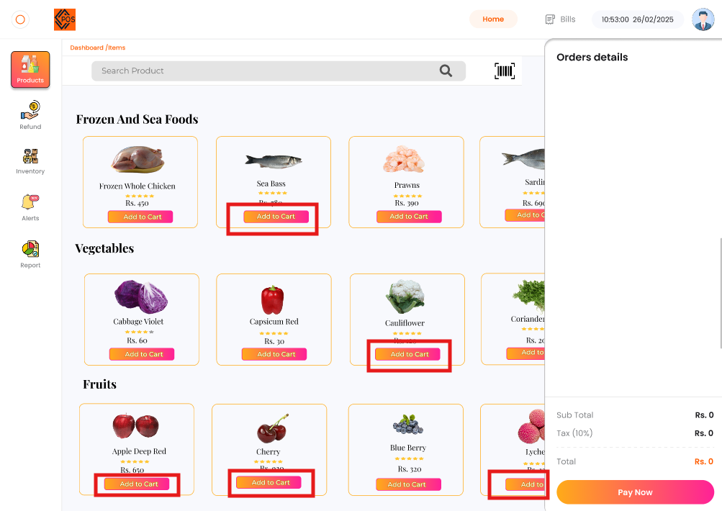

The product has been added to the **cart** using the **"Add to Cart"** button, which has been highlighted. This is how items are added to the cart.

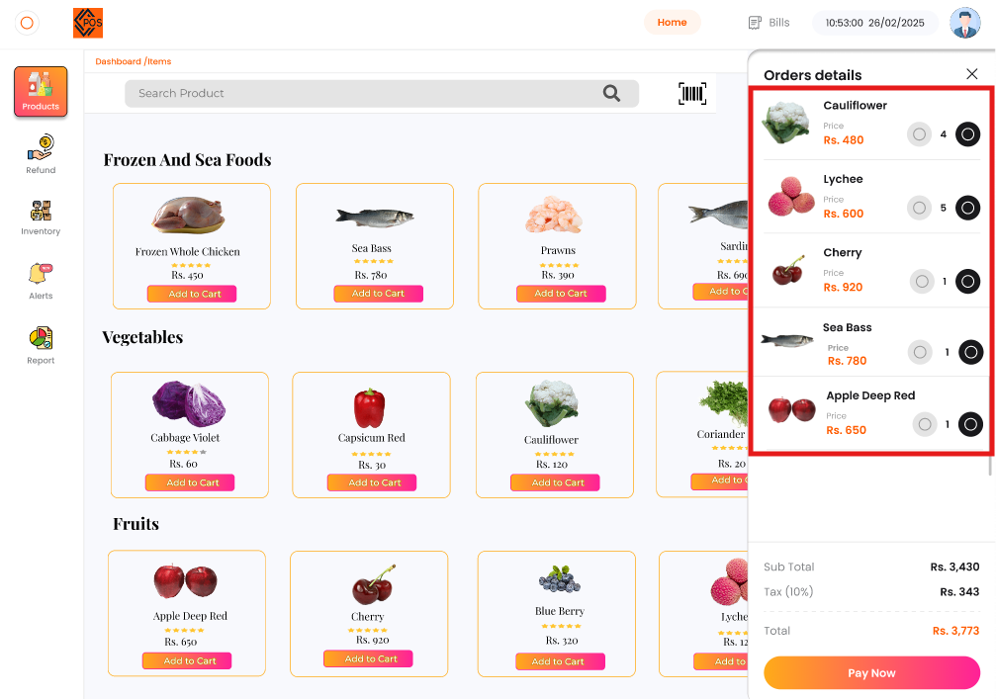

These products have been added to the **cart** and are now displayed after being added using the **"Add to Cart"** button.

**FR-2: Transaction Processing:**

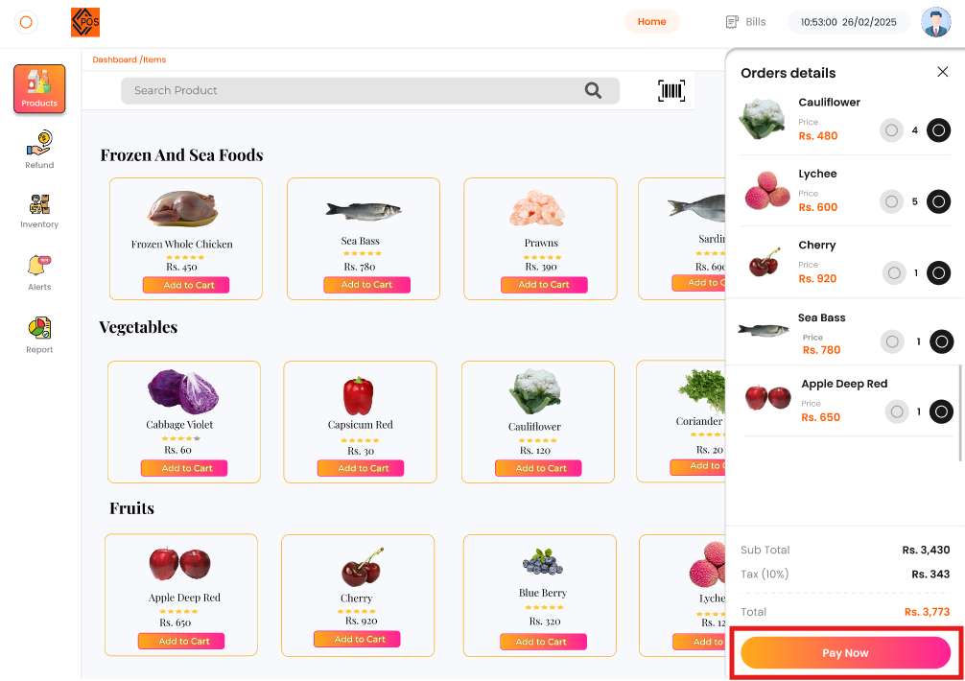**2.1. Payment Processing:**

The payment is processed using the **highlighted "Payment" button** after the items have been added to the cart.

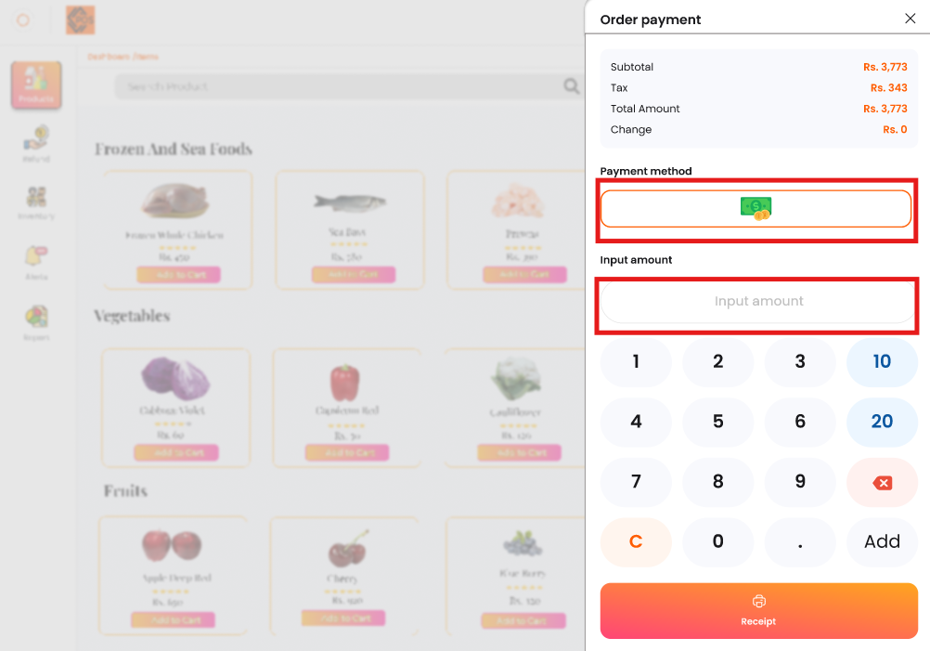

The payment method is **"By Cash,"** and the amount to be paid is entered accordingly.

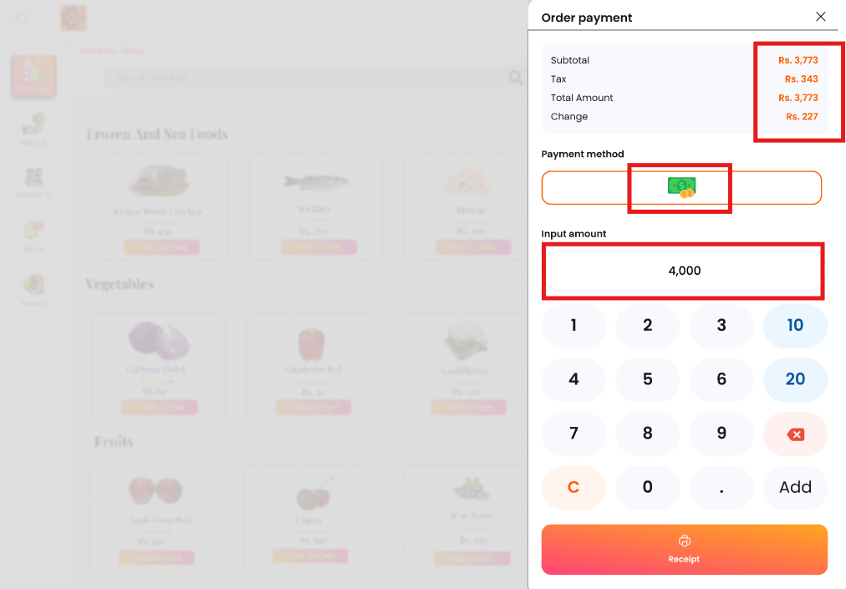

The amount has been entered, and based on that, the change will be calculated, and the payment will proceed successfully.

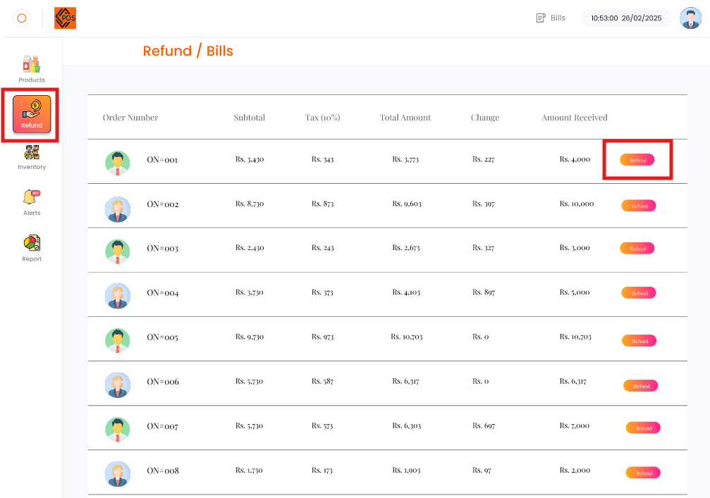**FR-3: Refunds:**

The refund will be processed by clicking on the **highlighted "Refund" button**.

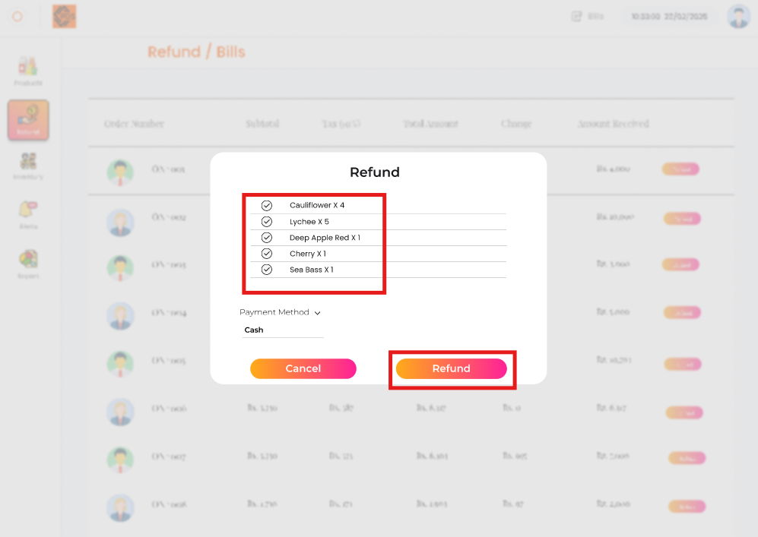

To process a refund, select the items to be refunded and click on the **"Refund"** button. The refund will be successfully completed.

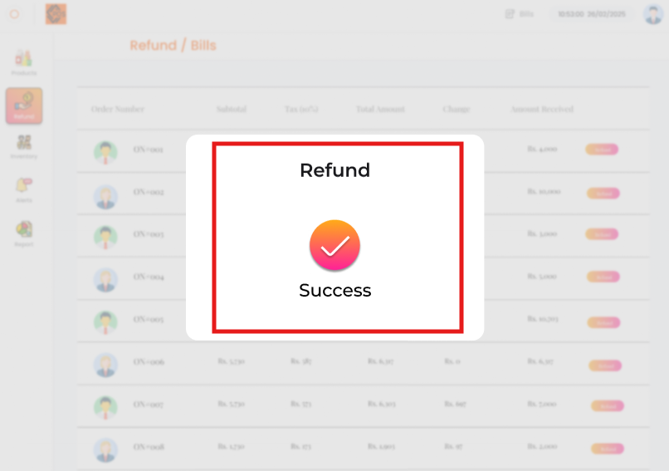

Once the refund process is complete, a **"Refund Successful"** message is displayed as a pop-up.

**FR-4: Inventory Management:**

**4.1. Update Inventory:**

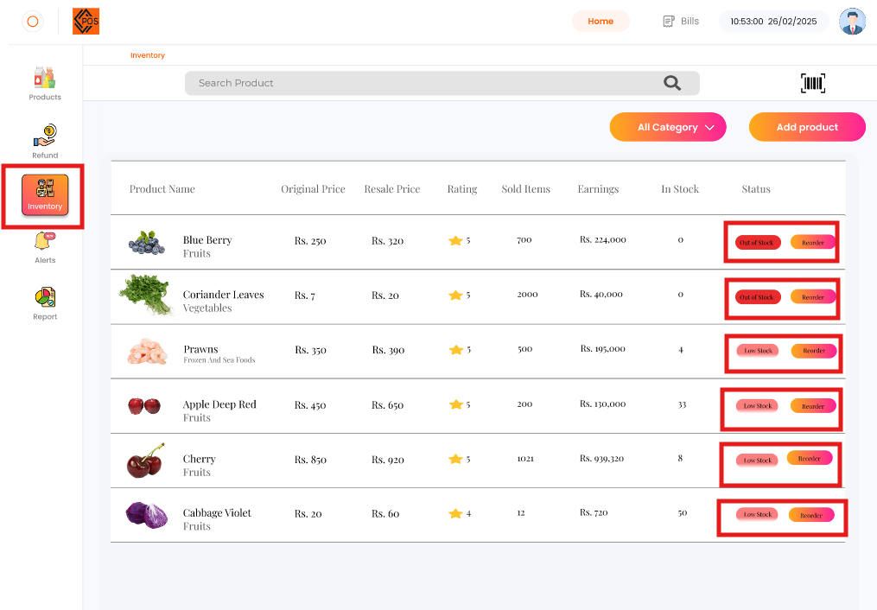

To update the inventory, click on the **highlighted "Inventory" button** to view the inventory. Low-stock items are displayed, and out-of-stock items can be restocked by clicking the **highlighted "Restock" button**. Once restocked, a **"Restock Order Successful"** pop-up 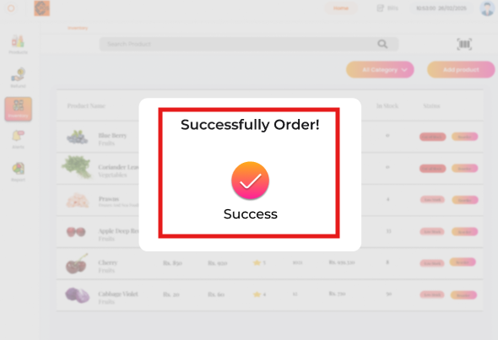message appears.

**4.2. Low Stock Alerts:**

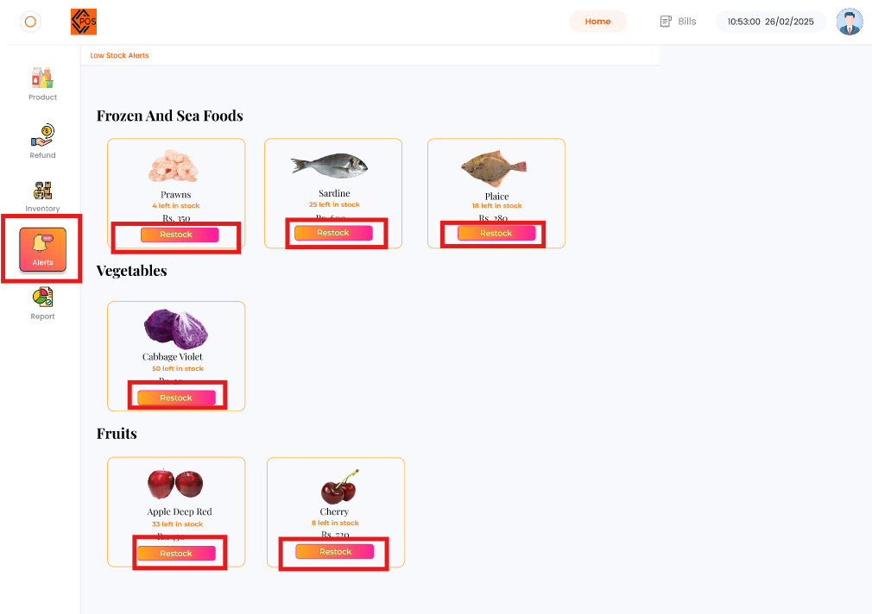

To view **low stock alerts**, click on the **highlighted button** to check which items need restocking. Then, click on the **highlighted "Restock" button** to restock the required items.

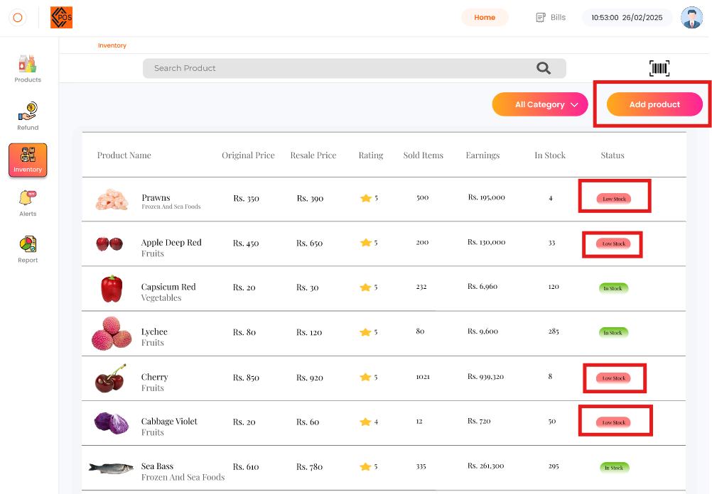

The **highlighted low-stock products** are restocked by clicking the **"Add Product"** button.

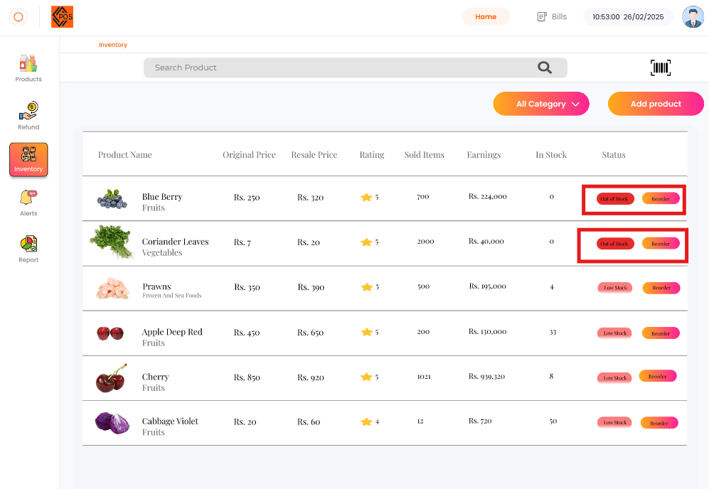

The **"Add Product"** button process continues as products are added. Low-stock products are reordered by clicking the **highlighted "Restock" button**. Once restocked, a **"Restock Order Successful"** pop-up message appears.



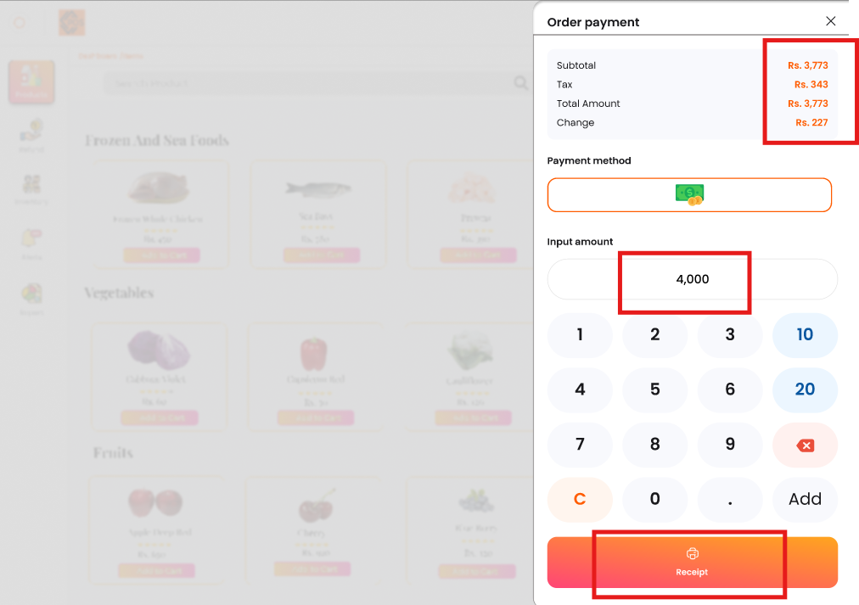**FR-5: Receipt Management:**

After the payment process, click on the **highlighted "Receipt" button** to generate the receipt.

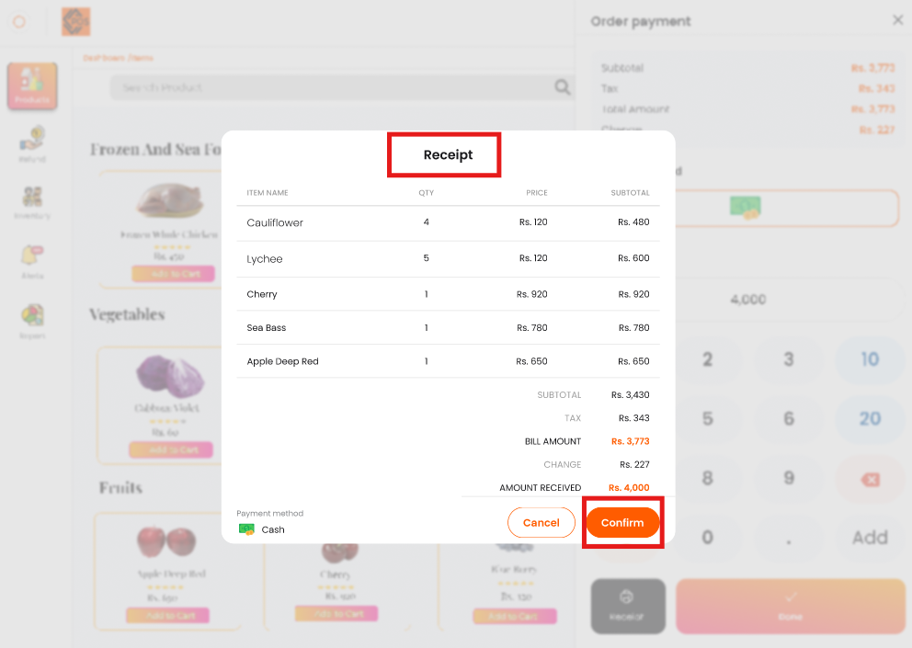

The receipt will be successfully generated.

**FR-6: Report:**

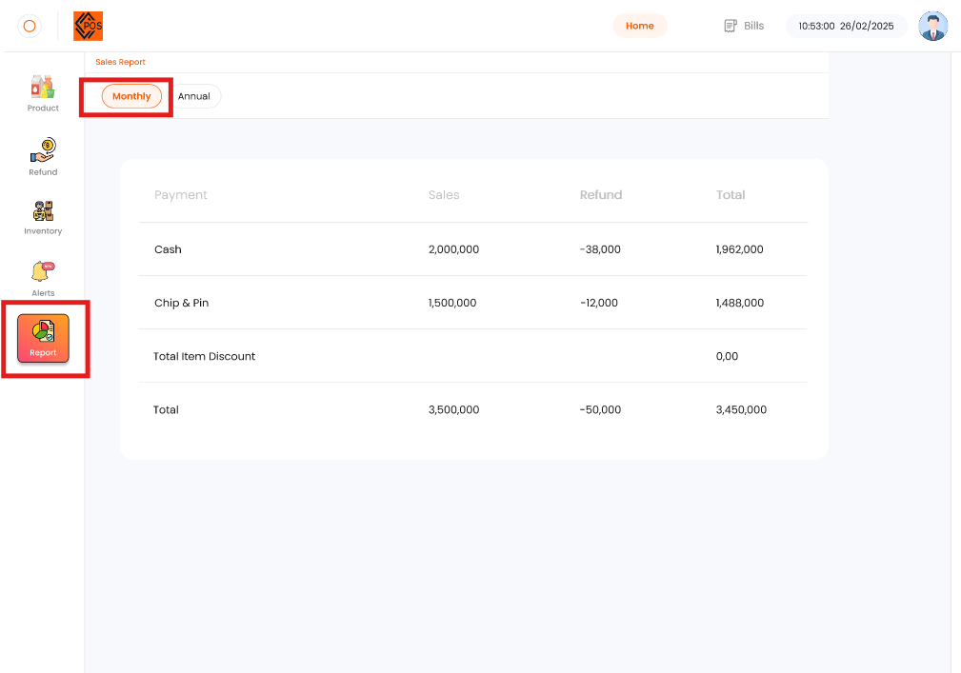

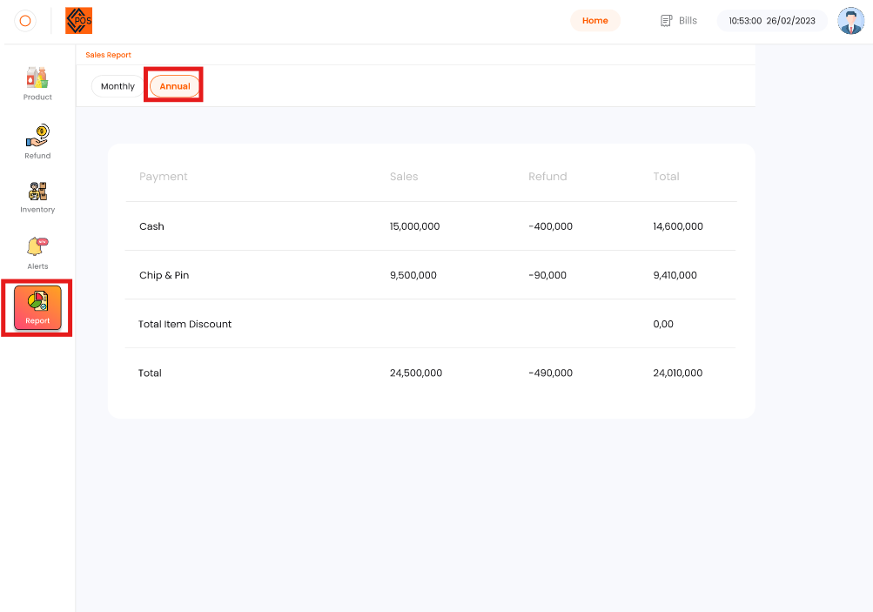

The report is displayed on a **monthly and annual basis** according to the **highlighted box**.

1. **SCD Project Status Report:**

**Date/Day: 25-02-2025**

**Project Name: POS (Point of Sale)**

**Project Lead: Maida Kosser**

**Report Date: 25-02-2025**

**Section: B**

|  |  |  |  |
| --- | --- | --- | --- |
| **Task** | **Member Roll #** | **Assigned Task** % | **Completed %** |
| **Mock ups Using Figma Tool** | 221400091 | 50% | 50% |
| 221400003 | 50% | 50% |
| **Total** | | 100% | 100% |

**Group No: 03**

**Project stage Completion Percentage: 100%**

**Comments:**

**______________________________________________________**

**______________________________________________________**

**Project Lead: _____________ Instructor: _______________**